STM32 programming interface
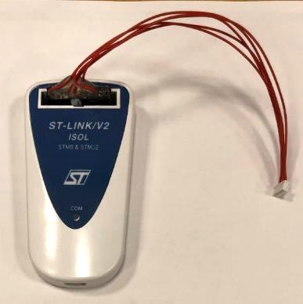

Any version of ST-Link can be used to program the STM32 microcontrollers. In the following picture is showed the ST-LINK/V2 ISOL, but also the ST-LINK/V2 and ST-LINK/V3 can be used.

Signal | Connector 1: Wurth Elektronik 61302021821 | Connector 2: Molex 51021-0500
RESET | Pin 15 | Pin 1
3.3 V | Pin 1 | Pin 2
GND | Pin 12 | Pin 3
DATA | Pin 7 | Pin 4
CLOCK | Pin 9 | Pin 5

